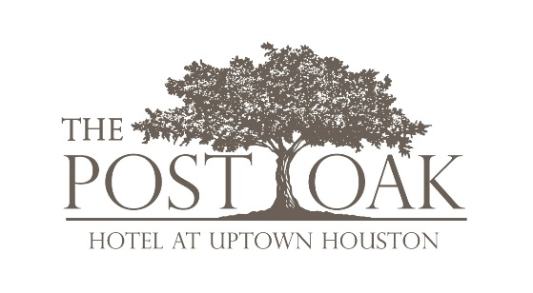

FOR IMMEDIATE RELEASE MEDIA CONTACTS:
Katelyn Roche Gosslee, Katelyn@dpwpr.com
Colleen Wagner, cwagner@dpwpr.com
Dancie Perugini Ware Public Relations
713.224.9115

BLOOM & BEE RESTAURANT INSIDE THE POST OAK HOTEL AT UPTOWN HOUSTON RECIEVES AAA FOUR-DIAMOND RATING
HOUSTON, TX (November 12, 2018) – The new Bloom & Bee inside The Post Oak Hotel at Uptown Houston is proud to announce the chic dining concept has earned the prestigious Four-Diamond Award from AAA for its renowned menu, whimsical ambiance, and first-class service.
“From the design and menu to our atmosphere and service, we wanted this concept to be a first of its kind in Houston,” said Tilman Fertitta. “Just like The Post Oak Hotel, Bloom & Bee delivers a luxury dining experience that is unrivaled in this city.”
Only nine other restaurants in Houston have received the AAA Four-Diamond award and not one restaurant in the market has been recognized with AAA’s Five-Diamond ranking.

Bloom & Bee, located on the first floor of the hotel, specializes in fresh, locally-inspired cuisine amid a garden-like setting which includes abstract hand-blown glass flowers strewn across the ceiling. Terrace dining is also available and overlooks the pool area. The plush velvet dining chairs, custom wallpaper and hand painted mirrors provide the ideal location for "ladies who lunch" in Space City.

Bloom & Bee’s Executive Chef Jean Luc Royere has delivered a breathtaking menu using only the season’s freshest ingredients from local farms and fisheries. Royere a vast breadth of culinary experience as a classically trained chef, as well as the distinction of being inducted to the renowned society of “Maîtres Cuisiniers de France” (Master Chef of France Association) in 2016. He has 10 years of experience working exclusively at Forbes Five-Star luxury properties across the country.
The Post Oak Hotel at Uptown Houston recently received the prestigious AAA Five-Diamond award within six months after opening, being the only hotel in Houston recognized with this honor. It is an unrivaled property, serving as a glittering beacon of Houston’s standing as a key destination in the Southwest.
Bloom & Bee is open from 6:30 a.m.-10:30 p.m. weekdays, 7 a.m.-10:30 p.m. on Saturday, and 7 a.m.-10 p.m. on Sunday. For more information or to make a reservation, please visit www.thepostoakhotel.com or call 346-227-5139.
ABOUT THE POST OAK HOTEL AT UPTOWN HOUSTON
The Post Oak Hotel at Uptown Houston is Houston’s newest destination for the discerning traveler. Set on 10 oak-studded acres, the sleek 38-story tower boasts 250 ultra-modern guestrooms and suites; 20 executive residences; and an elegant 35,000-square-foot conference facility, including the largest ballroom in the Uptown Houston area. Located mere steps from The Galleria and River Oaks District, The Post Oak Hotel caters to business and leisure travelers alike with lavish accommodations, five-fixture deluxe bathrooms, three televisions, sophisticated technology, and unobstructed views. While the standard guestroom offers 500 square feet of luxurious and abundant living space, the immense 5,000 square-foot, two-bedroom Presidential Suite is the most opulent of them all and serves as Houston’s unmatched, ultra-luxurious suite offering extra concealment and discretion with private elevator access, media room, exercise room and secluded terrace.

Unique amenities include a two-story Rolls-Royce showroom and on-site Bentley and Bugatti Post Oak Motors dealership, as well as six restaurants and bars throughout the hotel with dining choices from sophisticated cuisine in Bloom & Bee and exotic libations at H Bar to pub-style fare at Craft F&B and fresh-baked pastries at Bouchée Patisserie. Also on property is celebrity acclaimed and Texas’ first Mastro’s Steakhouse, as well as Willie G’s Seafood, a Houston institution with an amazing raw bar and seafood favorites. A multi-million-dollar modern art collection with pieces by Frank Stella, Alex Katz, Robert Motherwell, Donald Sultan, Joseph Glasco, and Howard Hodgkin are strategically placed throughout the hotel, giving it a museum-quality feel. The Cellar, the hotel’s expansive wine collection with over 30,000 bottles, offers guests and restaurant patrons access to more than $3 million of the world’s finest wines including vintages dating back to the 1800’s. Additional offerings for an effortless experience include the indulgent Post Oak Spa, Salon, and the hotel’s fashion-forward boutique, 29º North. The Post Oak Hotel is among 43 properties in the nation honored in the Preferred Hotels & Resorts Legends Collection, receiving the brand’s top-level accreditation for its high-quality standards and unparalleled service. To make a hotel reservation, please call 844.386.1600 or visit www.thepostoak.com.

###

